|  |  |  |  |  |  |
| --- | --- | --- | --- | --- | --- |
| Date | 7-Dec-22 | | | Tester Name | Mayuri Patel |
| Environment | Penfax - Test | | | Login used |  |
| Operating System | Select OS | Version: | Update: | | |
| Software Used | Select Software | Version: | Update: | | |
| Select Software | Version: | Update: | | |
| Release version | 22.4.1 | | | | |
| Title |  | | | | |
| Test Type | Regression | | | | |
| Test Scenario | annualized ROR -6 months, 1 yr., 2 yrs., 4 yrs. periods - PEPP and VPB | | | | |
|  |  | | | | |
| Expected Results |  | | | | |
| Pass/Fail | Pass | | | JIRA# | N/A |

Describe your steps with screenshots:

Search a PEPP Active member that has single fund and has contribution

Open that member profile

Make sure of the fund

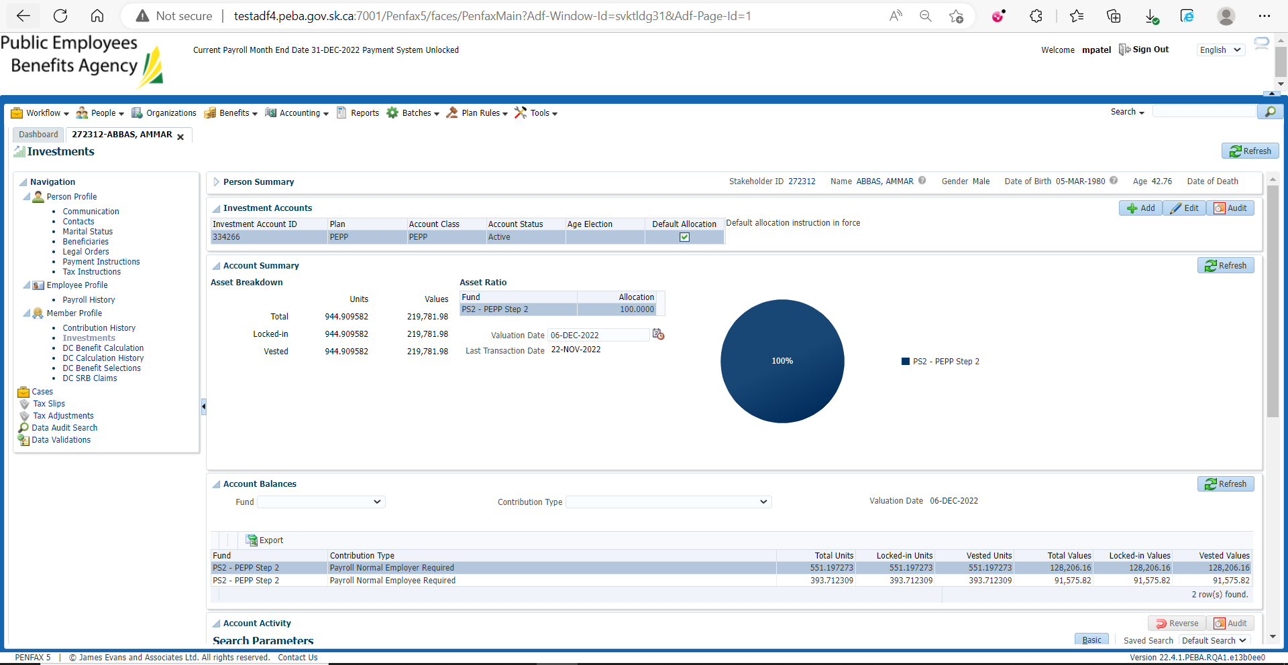

Make sure of contribution

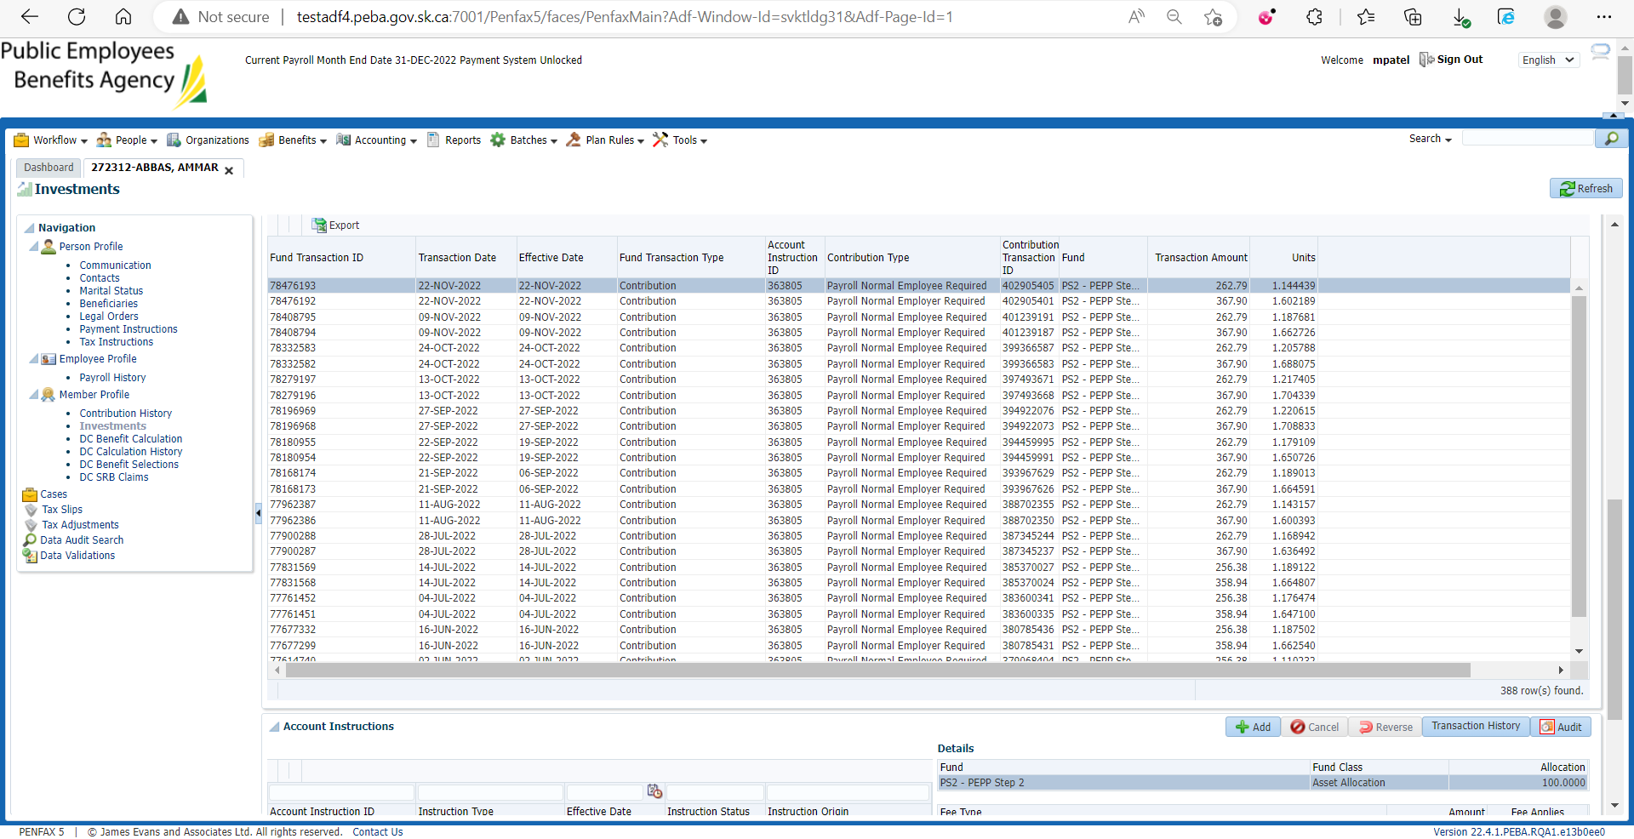

In Account Performance enter relevant details and search

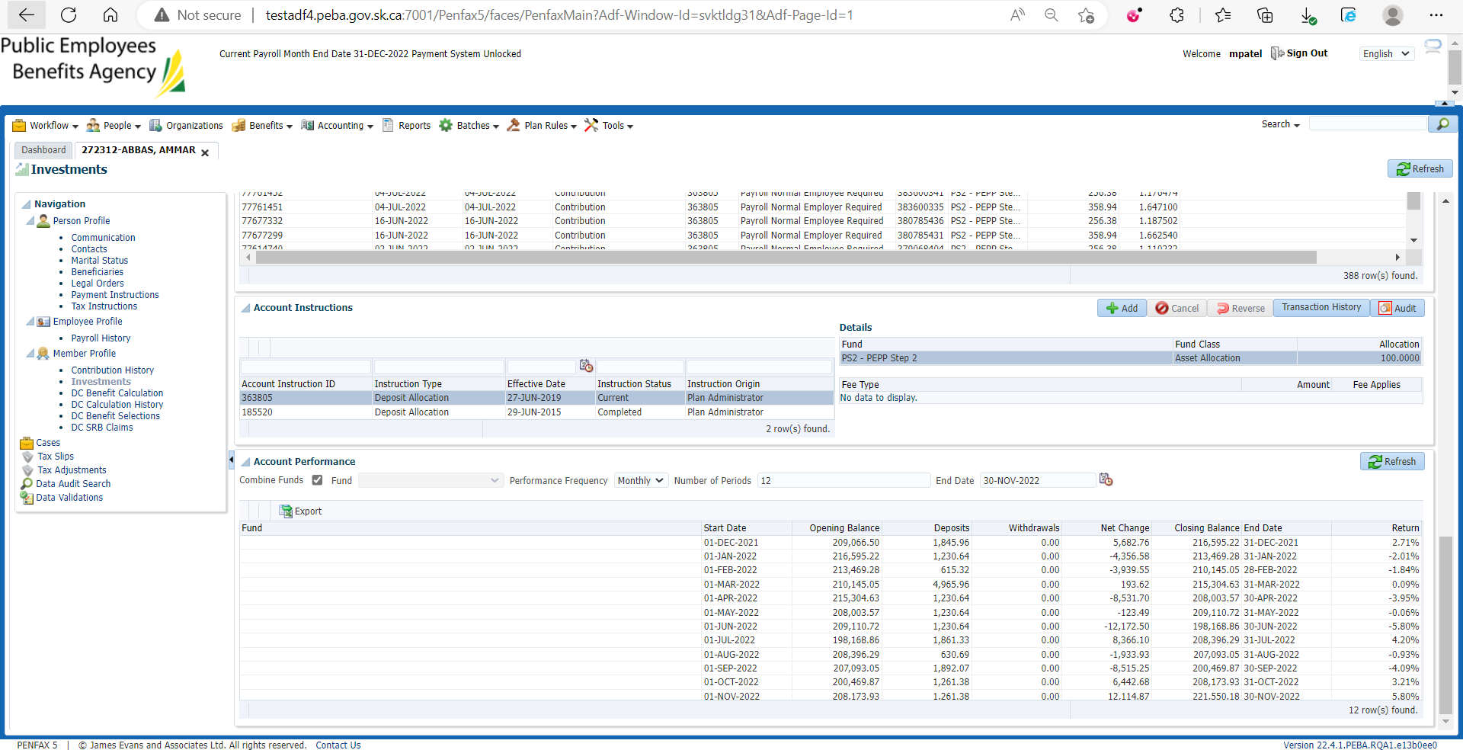

For 6-Month Rate of Return

(5.80) + (3.21) + (-4.09) + (-0.93) + (4.20) + (-5.80) = 2.39

In the spreadsheet for ROR paste the exported file from penfax and ensure the 6-month ROR is calculated properly

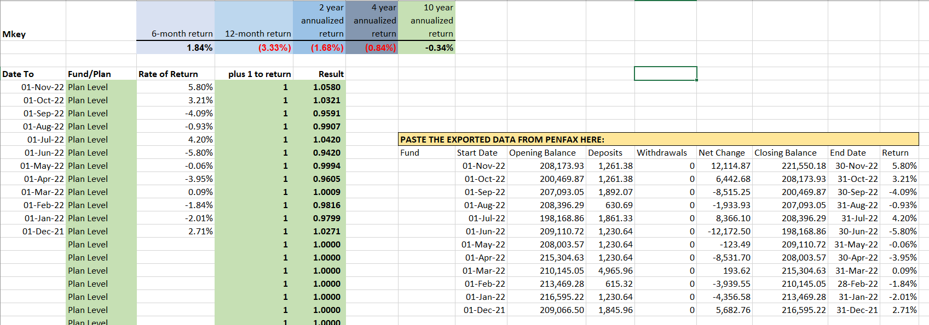

1-year Rate of Return

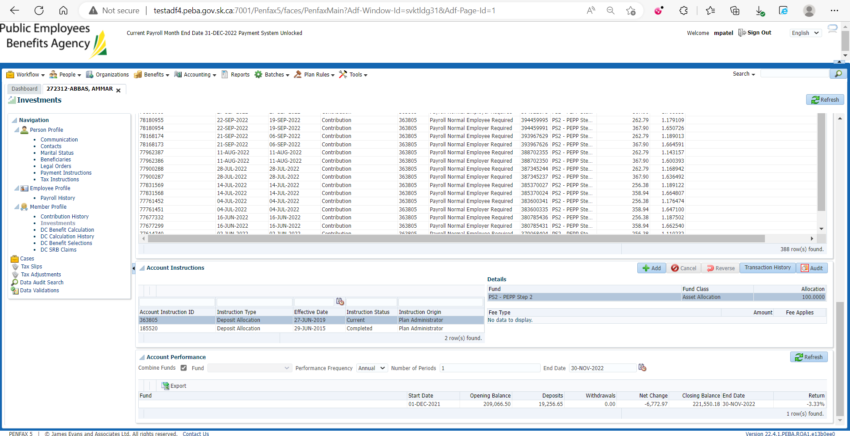



From the Communication outbound documents find PEPP March statement

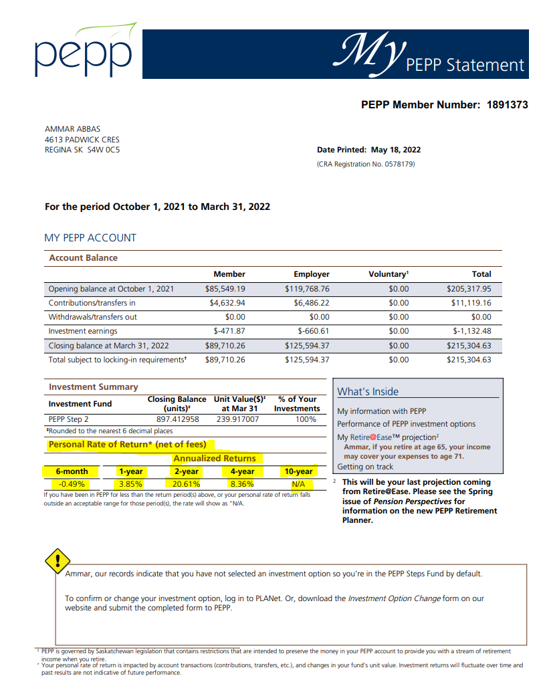

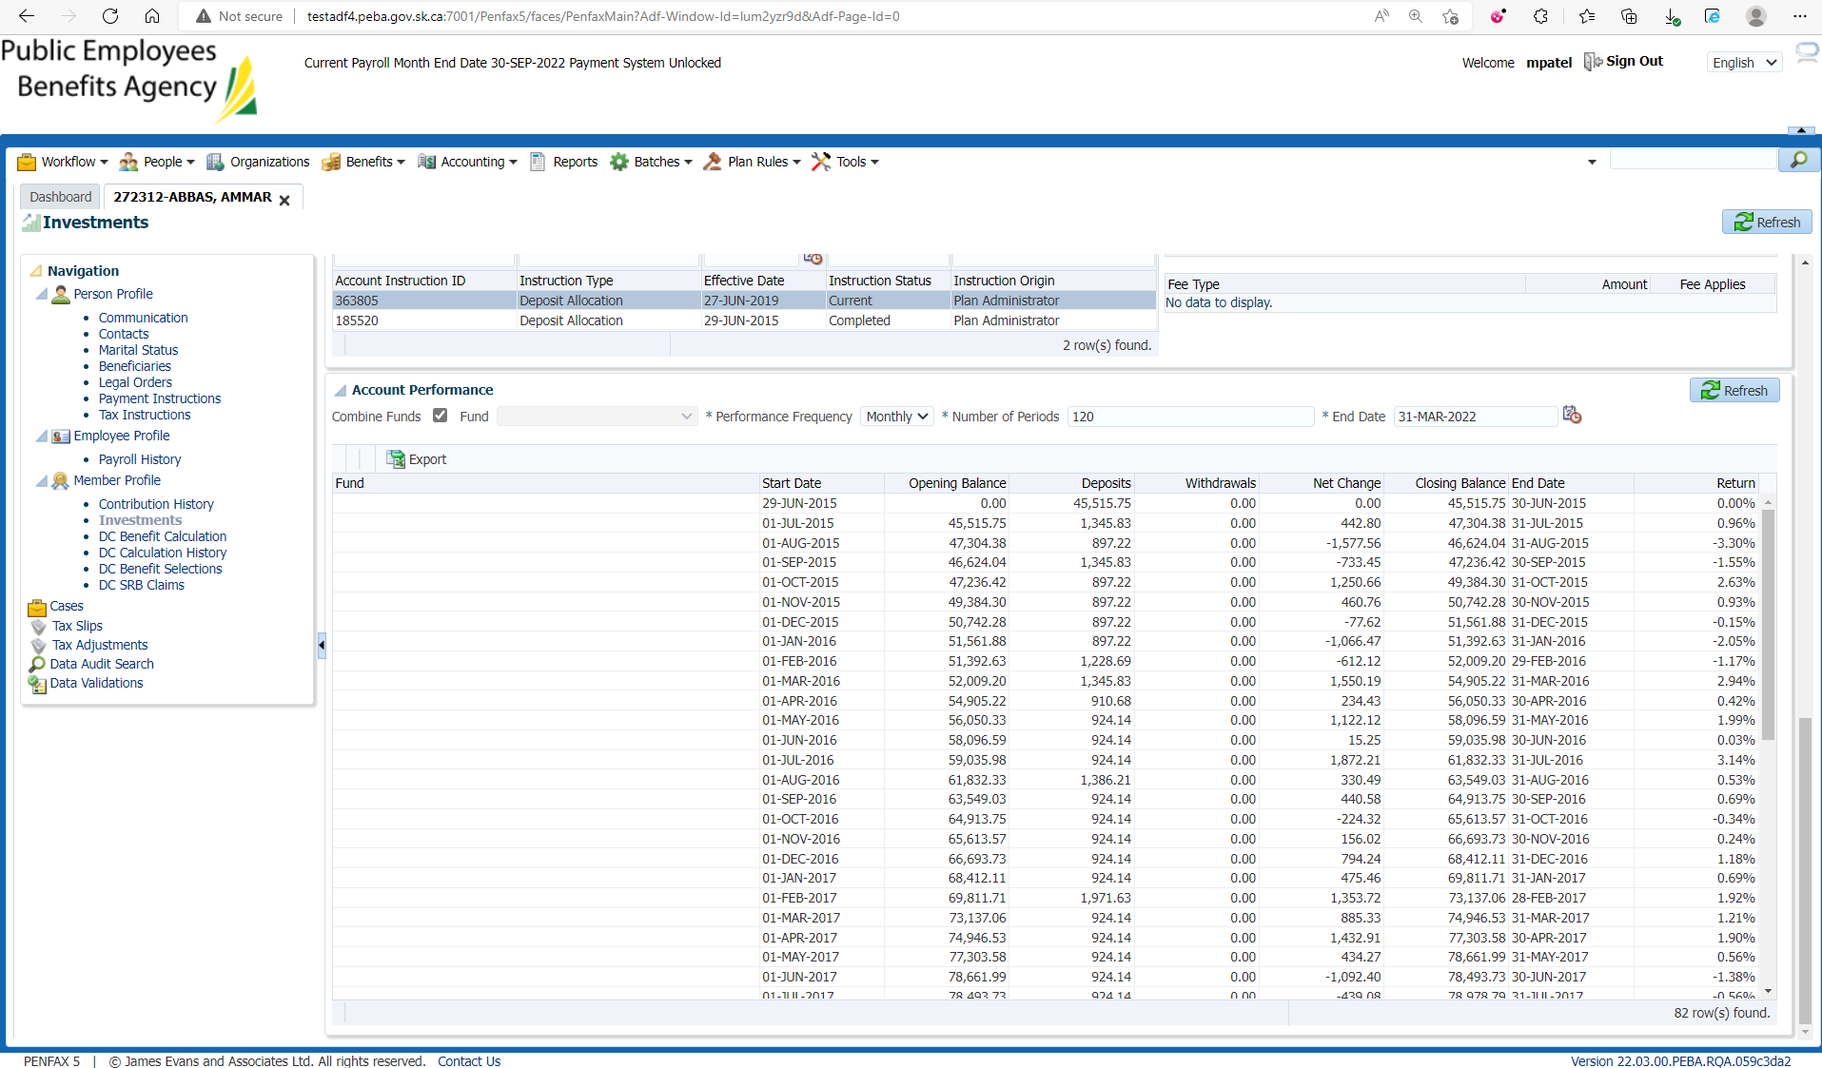

Make sure the 2-year, 4-year ROR is correct

